Press Release
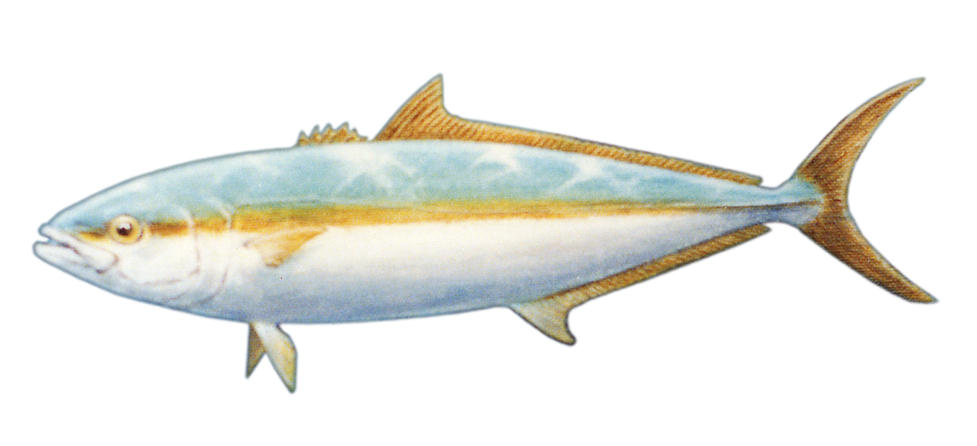
For all Media 5 Oct. 2009
Contact: John L. Campbell
(619) 991-5480 cell
Email: johncinsd@cox.net
Derby Winners Excited with Results and Awards

The Awards Ceremony was held at the Bali Hai Restaurant on Oct. 4 at 2 pm. The competitive assembled anglers praised the format and the results of the Derby. Many have volunteered to work on the 2010 International Yellowtail Derby.
Sonja Steiner from Ramona was the Overall winner with a 26 pound Yellowtail. She caught it at the Coronado Islands on Sept. 28 on Captain Steve Stachelski’s boat Tug Of War. She received many awards including the top cash prize, a trophy resembling a Hawaiian hook, Shimano rod, SeaTow membership, Sunroad Boat Show passes, Official 2009 Yellowtail Derby Sportsman shirt. She also received the Grand Prize, a Minn-Kota Saltwater Trolling Motor donated and presented by Bruce Biddick from Voodoo Sportfishing and CFB Marine Group. Sonja said, “ I will be back for the 2010 Derby.”
Final Results:
Overall 1 Sonja Steiner 2 Steve Stachelski 3 Hani Habib
Individuals Men 1 Steve Stachelski 2 Hani Habib 3 Kurt Hoffman
Open Party Men 1 Hani Habib

Sponsors in attendance were Kat Olhmann, Sunroad San Diego Boat Show, Capt. “Rags” Laragione of Maritime Institute, Capt. Severance of SeaTow Service, Bruce Biddick of Voodoo Sportfishing and CFB Marine Group, Susan Baumann of the Bali Hai, and Gus Giobi of Blue Sky News.

Fishing , this year, was on private boats and on the open party Sportfishing Fleet. The Derby ran for eight days. This is the first time the Derby has been run in 36 years. Two former Miss yellowtail Derby Queens came the Awards, Sharon Wetzel of 1962 and Kathy Harris of 1963. They brought pictures, brochures and spoke to the anglers of how it was “Back in the Day.”

The 2009 International Yellowtail Derby was sponsored and supported by the Port of San Diego, Sunroad Resort Marina, Sunroad San Diego Boat Show, the Maritime Institute, Seatow Services, CFB Marine Group, West Marine, San Diego Marine Exchange, AFTCO, The Bali Hai, To The Point Café, Precision Marine Hardware, Angler’s Choice Tackle, Fisherman’s Landing Tackle, Boyce Image, San Diego Port Tenants Assoc., Arizona Boating and Watersports and BlueSkyNews.com.
Headquarters was at the Outboard Boating Club at the Trailer Boat Ramp on Shelter Island Drive in San Diego. The mailing address is 3960 W. Point Loma Blvd. Ste H347, San Diego 92110.

The Website is www. InternationalYellowtailDerby.com
.

